

C PROGRAMMING ASSIGNMENT
Student Submission Template
Student Name | ROHITHKUMAR R
Register Number | 1911260135
Course Code & Name | CSA0211
Slot | D
Assignment / Task Title | CO-1 AT-1
GitHub Repository URL | https://github.com/Rohith45-ultra/CSA0211-1911260135-Cprogramming.git
Submission Date | 28/10/2026

TASK 1 Understand the Problem and Identify the Data
Task / Problem Statement
Analyse the Grama Jyothi rural electricity billing problem. Identify inputs, outputs, constants, computed values, rules, and assumptions.
Aim
To identify all data needed to calculate correct household electricity bills and explain why each data item is suitable.
Concept / Theory
Inputs are household ID, category, previous reading, and current reading. Outputs are consumed units, energy charge, fixed
charge, and total. Tariff limits/rates are constant during a run. Integer readings suit whole meter counts; money stored in paise
avoids fractional currency errors. A meter can roll over from 65535 to 0 Procedure / Algorithm
- List all input data items.
- Identify computed values and outputs.
- Separate fixed tariff values from changing readings.
- Write correctness rules, including non-negative bills and total = energy charge + fixed charge.
- State assumptions about rollover and tariff slabs.

Program / Source Code
#include <stdio.h> #include <limits.h>

typedef unsigned short meter_t;

unsigned int consumption(meter_t previous, meter_t current)
{
return (meter_t)(current - previous);
}

int main(void)
{
printf("Maximum meter reading: %u\n", (unsigned)USHRT_MAX);

printf("Normal consumption: %u units\n", consumption(1200, 1530));

printf("Rollover consumption: %u units\n", consumption(65400, 120));

return 0;
}

Output Screenshot

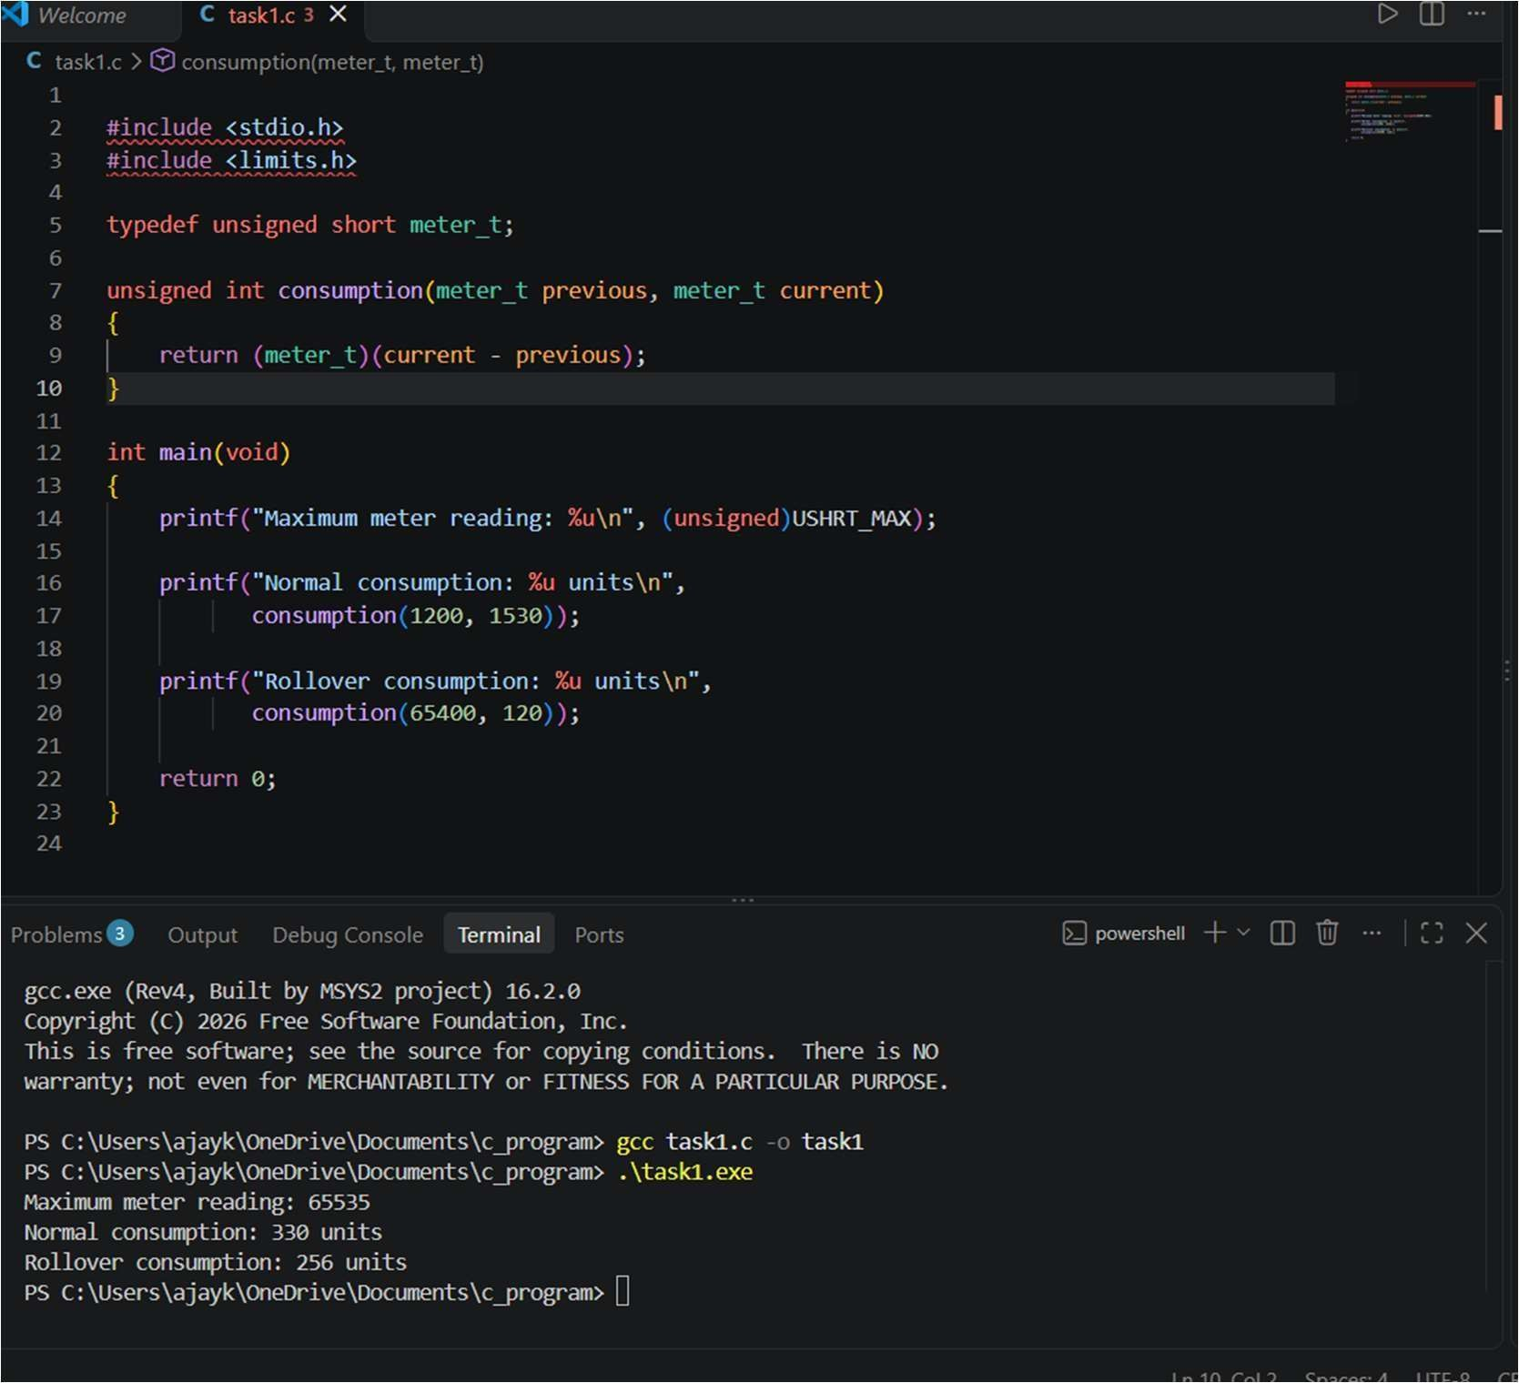

Analysis / Discussion
Use a table in your final version to justify each data type. If readings are stored as strings, conversion/comparison takes O(d) time for d digits and O(d) storage per reading; fixed-width integer reading operations are O(1). The supplied starter assumptions treat
readings as 16-bit and use 100 free units, Rs 2.25 per unit for units 101–200, Rs 4.50 per unit above 200, and a Rs 50 fixed charge.
Result
The problem requirements and billing conditions were identified to establish the logic needed for the electricity billing program.

TASK 2 — Choose the Data Types
Task / Problem Statement
Choose appropriate C types for the billing program and demonstrate sizes, ranges, rollover behaviour, and currency precision.
Aim
To select types that can represent meter readings and large bill totals without avoidable overflow or rounding errors
Concept / Theory
Use sizeof and limits.h/float.h to inspect implementation-specific sizes and ranges. Integer paise represents whole-paise money exactly. A 16-bit unsigned counter wraps modulo 65536. C type sizes vary by compiler/platform.

Procedure / Algorithm
- Compile and run the type-inspection program.
- Record the sizeof and limits shown by your system.
- Compare the maximum district-scale total with type limits.
- Demonstrate integer division and floating-point precision examples.
- Explain why money is stored in paise.

Program / Source Code File: Task02_types.c
#include <stdio.h> #include <limits.h> #include <float.h> #include <stdint.h>

int main(void)
{
printf("sizeof(short) = %zu bytes; USHRT_MAX = %u\n", sizeof(short), (unsigned)USHRT_MAX); printf("sizeof(int) =
%zu bytes; INT_MAX = %d\n", sizeof(int), INT_MAX); printf("sizeof(long) = %zu bytes; LONG_MAX = %ld\n", sizeof(long), LONG_MAX);
printf("sizeof(long long) = %zu bytes; LLONG_MAX = %lld\n", sizeof(long long), LLONG_MAX);
printf("sizeof(float) = %zu bytes; FLT_DIG = %d\n", sizeof(float), FLT_DIG);
printf("sizeof(double) = %zu bytes; DBL_DIG = %d\n", sizeof(double), DBL_DIG);
printf("sizeof(uint16_t) = %zu bytes; maximum = 65535\n", sizeof(uint16_t));

return 0;
}

Output Screenshot
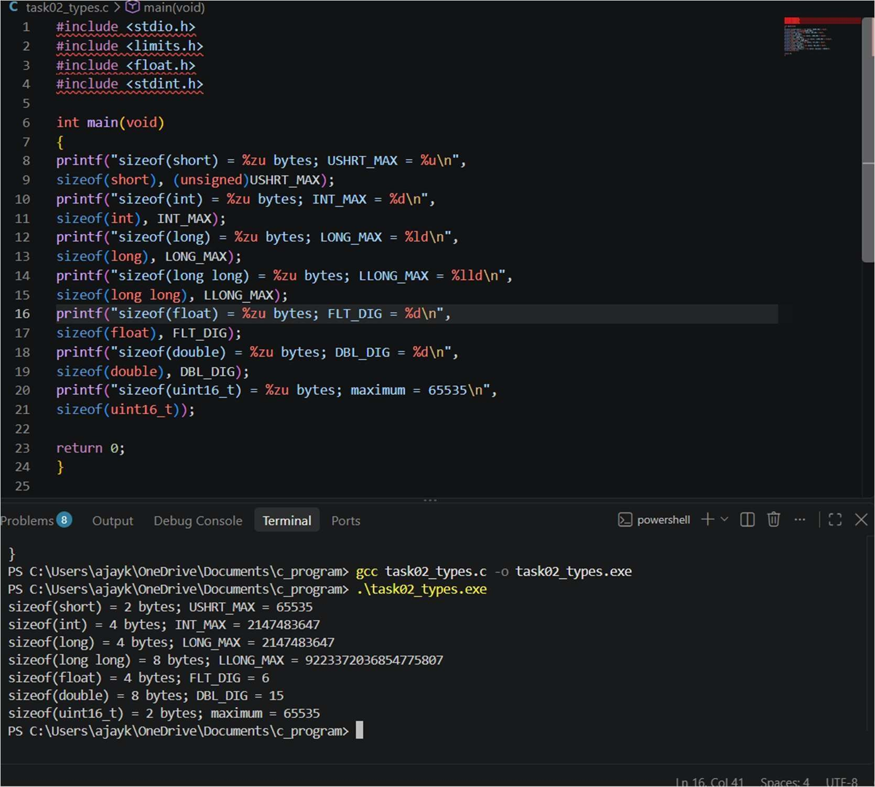
Analysis / Discussion
Do not assume every platform has identical sizes. The code prints local compiler values. For rollover from 65400 to 120, 16-bit modular arithmetic gives 256 units. The precision demonstration is in Task07_precision.c. Add your own measured comparison for 4,000, 60,000, and 800,000 bills.
Result
The appropriate C data types and variables were identified to store electricity consumption and billing information.

TASK 3 — Define the Constants
Task / Problem Statement
Define tariff rates and slab limits once so tariff revisions are consistent throughout the program. Aim
To use clearly named constants and calculate bills using the required slab rates Concept / Theory
#define macros are replaced by the preprocessor and do not have ordinary variable storage. const objects have a type and scope. enum is suita
Procedure / Algorithm
- Define slab limits and rates.
- Calculate the charge for each slab.
- Add the fixed charge.
- Run all provided test unit counts.
- Change RATE2_PAISE to 230 and rerun to confirm consistency

Program / Source Code
File: Task03_tariff.c #include <stdio.h>
#define SLAB1_UNITS 100
#define SLAB2_UNITS 200 #define RATE1_PAISE 0L #define RATE2_PAISE 225L #define RATE3_PAISE 450L
#define FIXED_CHARGE_PAISE 5000L
long compute_bill(int units)
{
long paise = FIXED_CHARGE_PAISE; int slab2_units = 0; int
slab3_units = 0; if (units < 0) { return -1L;
}

if (units > SLAB1_UNITS) { slab2_units
= units < SLAB2_UNITS ? units - SLAB1_UNITS
: SLAB2_UNITS - SLAB1_UNITS;
}
if (units > SLAB2_UNITS) { slab3_units = units - SLAB2_UNITS;
}
paise += (long)slab2_units * RATE2_PAISE; paise += (long)slab3_units * RATE3_PAISE;
paise += (long)(units < SLAB1_UNITS ? units : SLAB1_UNITS) * RATE1_PAISE; return paise;
}
int main(void)
{
int tests[] = {0, 100, 150, 200, 350}; int n = (int)(sizeof tests / sizeof tests[0]);
for (int i = 0; i < n; i++) { long p
= compute_bill(tests[i]);
printf("%3d units -> Rs %ld.%02ld\n", tests[i], p / 100, p % 100);
}
return 0;
}
Output Screenshot
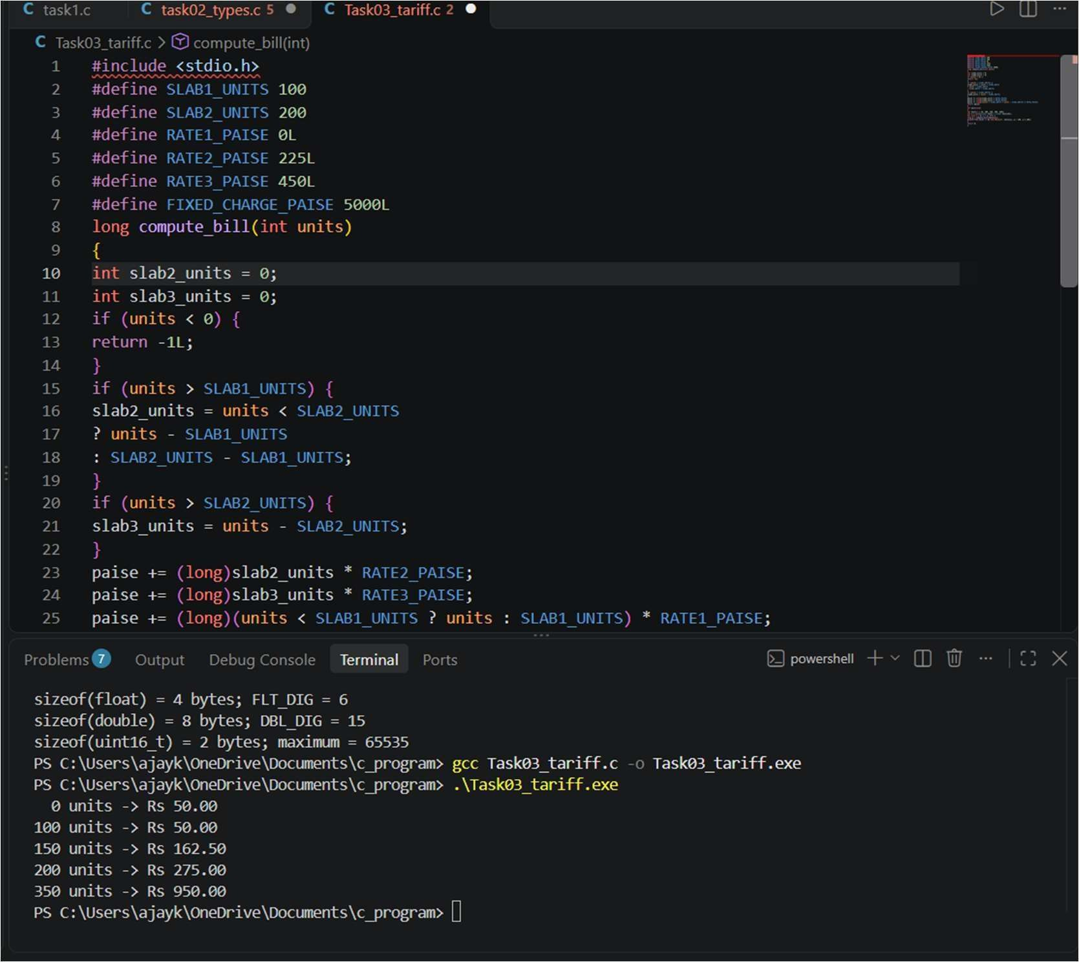

Analysis / Discussion
The program uses integer paise. Expected results under the specified tariff: 0 and 100 units = Rs 50.00; 150 units = Rs 162.50;
200 units = Rs 275.00; 350 units = Rs 950.00. If the rate is revised, change one macro and rebuild Result
The tariff calculation logic was developed to calculate electricity charges according to the specified billing slabs.

TASK 4 — Use Macros Safely
Task / Problem Statement
Create and test macros for repeated calculations and explain preprocessor expansion and macro pitfalls.
Aim
To write fully parenthesized macros and understand when a function is safer. Concept / Theory
Macro parameters should be parenthesized, and the whole expression should be parenthesized. A macro such as x*x can produce
incorrect precedence for SQUARE(a+1). MAX(a++, b++) may evaluate a parameter more than once, so functions are safer with side effects.
Procedure / Algorithm
- Compile and run Task04_macros.c.
- Observe SQUARE(a + b) and MAX(a, b).
- Run gcc -E Task04_macros.c and inspect expansion.
- Explain why function calls are safer for arguments with side effects.
- Compare macro expansion with a static inline function Program / Source Code
File: Task04_macros.c #include <stdio.h>
#define SQUARE(x) (((x) * (x))) #define MAX(a, b) (((a) > (b)) ? (a) : (b)) static int square_int(int x)
{
return x * x;
}
int main(void)
{ int a = 3; int b = 4;
printf("SQUARE(a + b) = %d\n", SQUARE(a + b)); printf("MAX(a, b) = %d\n", MAX(a, b)); printf("square_int(a + b) = %d\n", square_int(a + b));
/* Do not use MAX(a++, b++): a macro may evaluate an argument more than once. */ return 0;
}

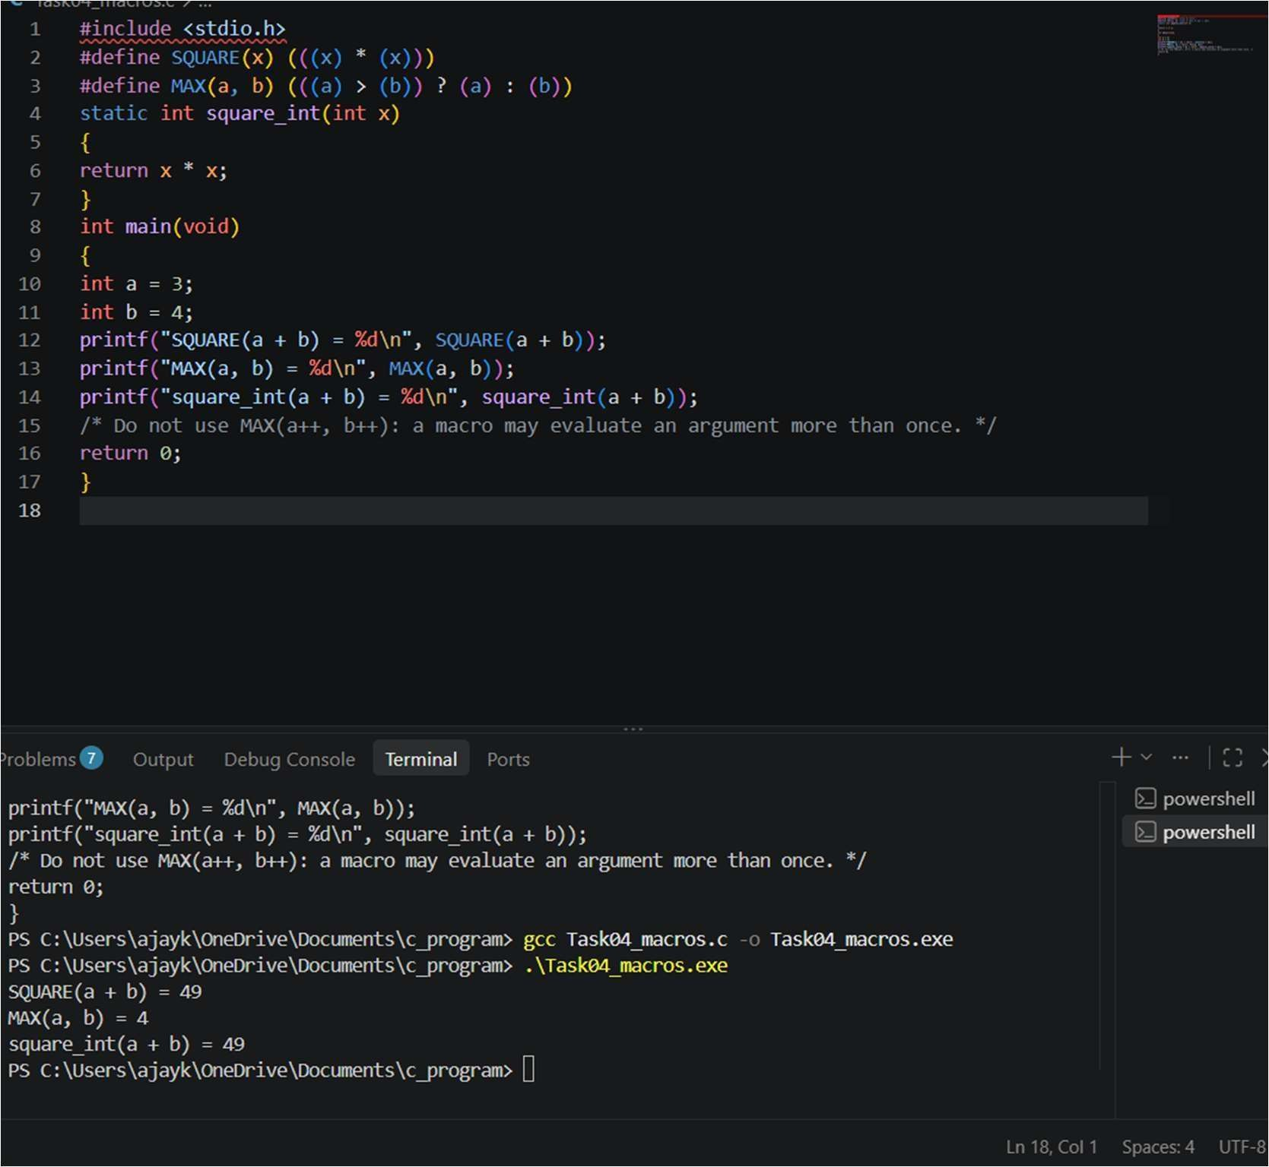

Analysis / Discussion
The provided SQUARE macro uses parentheses around each parameter and the whole expression. Do not pass increment operations into MAX. Include a screenshot of the gcc -E command output as evidence. Result
Macros were defined to represent fixed billing values, making the program easier to maintain and modify.

